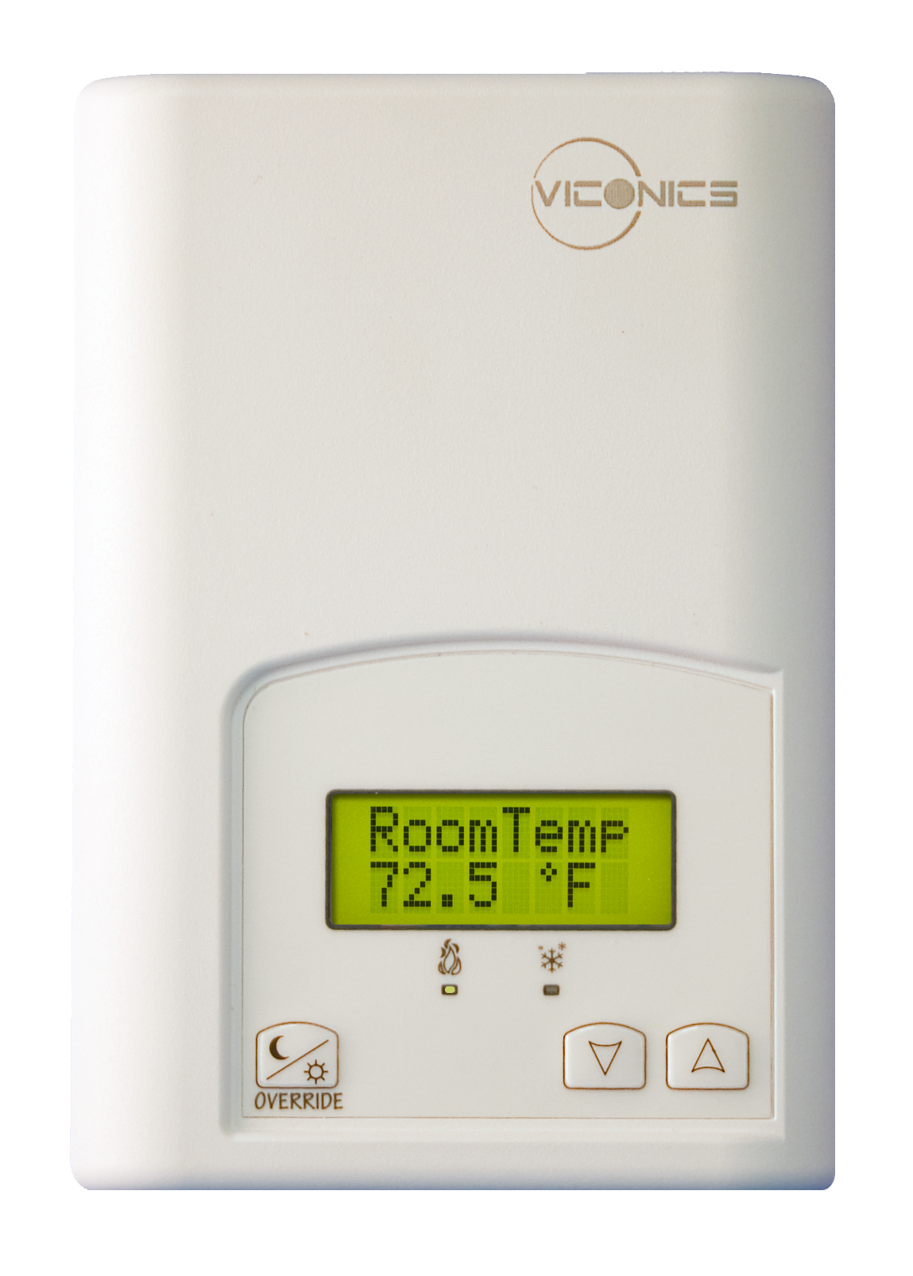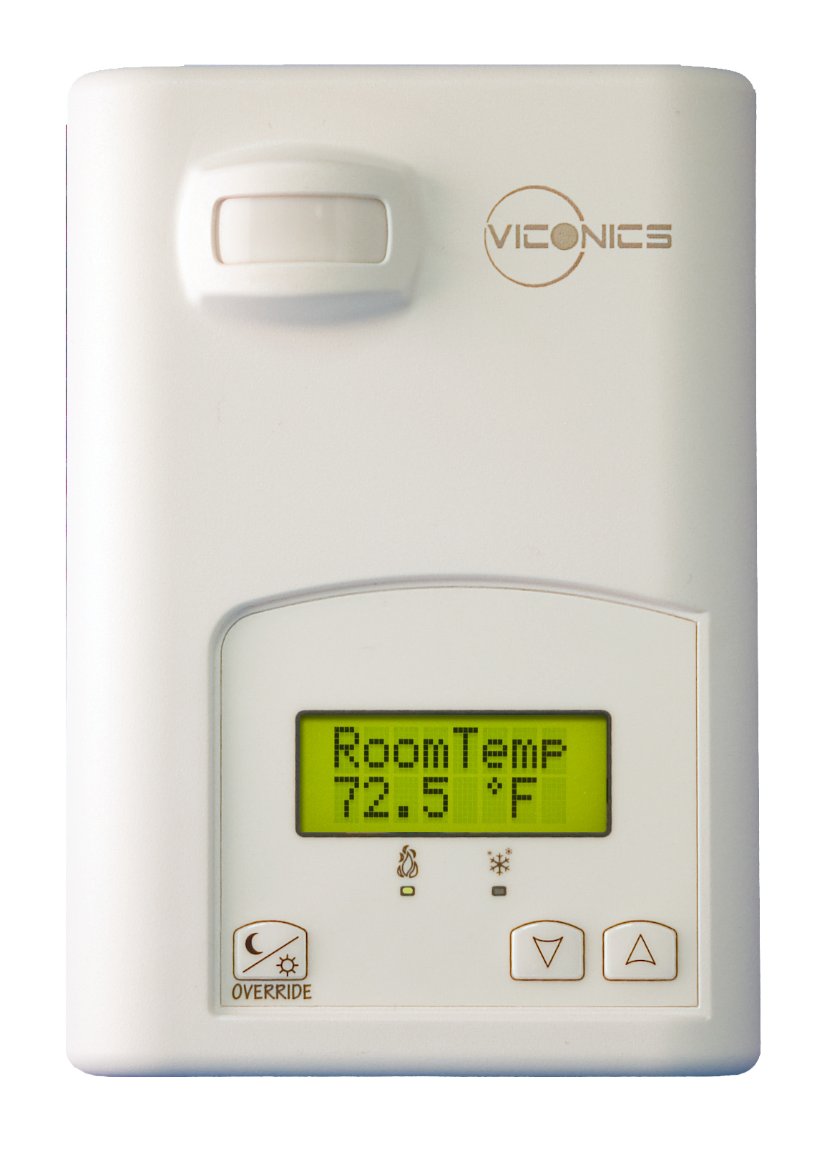
VZ7200 Series
Protocol Implementation Conformance Statement (PICS)
Last revision: July 5th, 2011

Vendor Name: Viconics
Product Name: VZ7200 Zoning System Zone Thermostat
Product Model Number: VZ7200F5x00B
Product Version: 1.02.11
BACnet Protocol Revision: 4 (135-2004)

Product Description

The Viconics VZ7200 PI thermostat family is specifically designed for local pressure dependent VAV zone control within Viconics Zoning System product family.
The thermostats are used in conjunction with the Viconics VZ7656B1000B Roof Top Controller thermostat for total system operation of each zones and the RTU.

BACnet Standardized Device Profile (Annex L):
□ BACnet Operator Workstation (B-OWS)
□ BACnet Building Controller (B-BC)
□ BACnet Advanced Application Controller (B-AAC)
☑ BACnet Application Specific Controller (B-ASC)
□ BACnet Smart Sensor (B-SS)
□ BACnet Smart Actuator (B-SA)

BACnet Interoperability Building Blocks Supported (Annex K):

BACnet Interoperability Building Block | Supported
Data Sharing COV-B (DS-COV-B) | ☑
Data Sharing-ReadProperty-B (DS-RP-B) | ☑
Data Sharing-ReadPropertyMultiple-B (DS-RPM-B) | ☑
Data Sharing-WriteProperty-B (DS-WP-B) | ☑
Device Management-Dynamic Device Binding-B (DM-DDB-B) | ☑
Device Management-Dynamic Object Binding-B (DM-DOB-B) | ☑
Device Management-DeviceCommunicationControl-B (DM-DCC-B) | ☑

The following BACnet Interoperability Building Blocks supported are used ONLY with the VZ7656B1000B Roof Top Controller for system operation. The following BiBBS are NOT listed under the “protocol service supported” device attribute. As such, the VZ7200 application cannot use these services to communicate with “other” third party devices (see Annex K in BACnet 2004):

BACnet Interoperability Building Block | Supported
Data Sharing COV-A (DS-COV-A) | ☑
Data Sharing-ReadProperty-A (DS-RP-A) | ☑
Data Sharing-WriteProperty-A (DS-WP-A) | ☑

Segmentation Capability:
Segmented Requests Supported | □ | Window Size: | N/A
Segmented Responses Supported | □ | Window Size: | N/A
Standard Object Types Supported:
Object Type | Supported | Dynamically  Creatable | Dynamically  Deletable | Optional  Properties  Supported | Writable Properties
Analog Input | ☑ | □ | □ | Reliability | Out_of_Service
Analog Value | ☑ | □ | □ | Reliability | Present_Valueª  Out_of_Service
Binary Input | ☑ | □ | □ | Reliability  Active_Text  Inactive_Text | Out_of_Service
Binary Value | ☑ | □ | □ | Reliability  Active_Text  Inactive_Text | Present_Value^{b}  Out_of_Service
Device | ☑ | □ | □ | Max_Master  Max_Info_frames | Object_Identifier  Object_name  Max_Master
Multi-state Value | ☑ | □ | □ | Reliability  States_Text | Present_Value^{c}  Out_of_Service

a: Present_Value property is writable for every AV objects except :
- Cfg Zone MAC (AV1)
- Cfg RTC MAC (AV2)
- GUI AO2 Status (AV17)
- GUI UI3 Status (AV18)
- GUI PI Heat Weighted Demand (AV19)
- GUI PI Cool Weighted Demand (AV20)
- GUI Room Temperature (AV21) ( Present Value can be only be written if BV10 GUI Room Temp Override is set to true )
- GUI Outdoor Temperature (AV22)
- Cfg Device Instance (AV23) – This object is not writable even when OUT OF SERVICE is TRUE. Changing the device ID will affect communication to the device even is OUT OF SERVICE is TRUE, so it’s not recommended.

b: Present_Value property is writable for every BV objects except :
- GUI BO5 Status (BV7)
- Sta AO2 Lock Status (BV8)
- Sta BO5 Lock Status (BV9)
- Sta RTC Prog Recovery (BV11)

c: Present_Value property is writable for every MV objects except :
- Cfg Zone Baud (MV1)
- GUI Occupancy (MV9) ( Present Value can be only be written permanently if MV7 Cfg Network Handle is set to index 2 or 3. Index 1 resets present value as per application )
- GUI Effective Occupancy (MV11)
Data Link Layer Options:
□ BACnet IP, (Annex J)
□ BACnet IP, (Annex J), Foreign Device
□ ISO 8802-3, Ethernet (Clause 7) (10Base2, 10Base5, 10BaseT, Fiber)
□ ANSI/ATA 878.1, 2.5 Mb. ARCNET (Clause 8)
□ ANSI/ATA 878.1, RS-485 ARCNET (Clause 8), baud rate(s):
☑ MS/TP master (Clause 9), baud rate(s): 9600, 19200, 38400, 76800 (Auto Baud)
□ MS/TP slave (Clause 9), baud rate(s):
□ Point-To-Point, EIA 232 (Clause 10), baud rate(s):
□ Point-To-Point, modem, (Clause 10), baud rate(s):
□ LonTalk, (Clause 11), medium:
□ Other:

Device Address Binding:
Is static device binding supported? □ Yes ☑ No
(Necessary for two-way communication with MS/TP slaves and certain other devices.)

Networking Options:
Router | N/A
Annex H, BACnet Tunnelling | N/A
BACnet/IP Broadcast Management Device (BBMD) | N/A
Does the BBMD support registrations by Foreign Devices? | N/A

Character Sets Supported:
☑ ANSI X3.4 | □ IBM/Microsoft DBCS | □ JIS C 6226
□ ISO 10646 (ICS-4) | □ ISO 10646 (UCS2) | □ ISO 8859-1

If this product is a communication gateway, describe the types of non-BACnet equipment/networks(s) that the gateway supports:
Not applicable.

