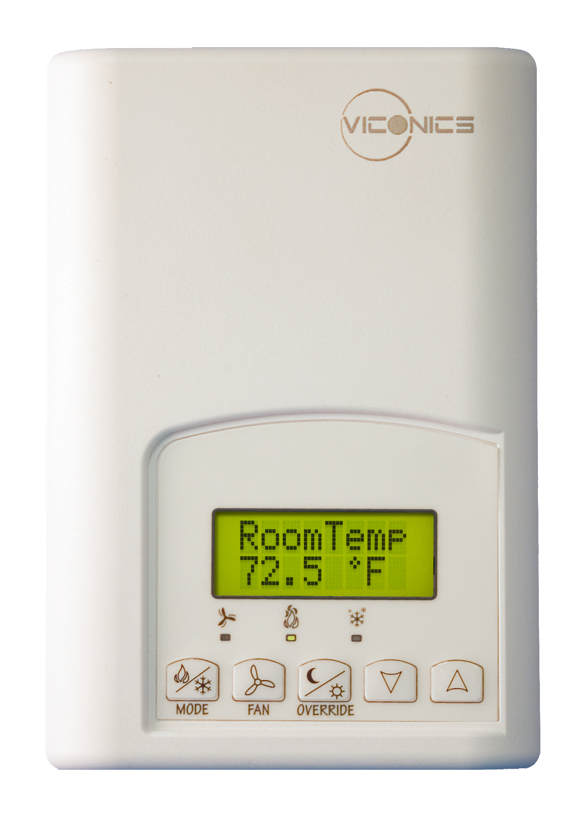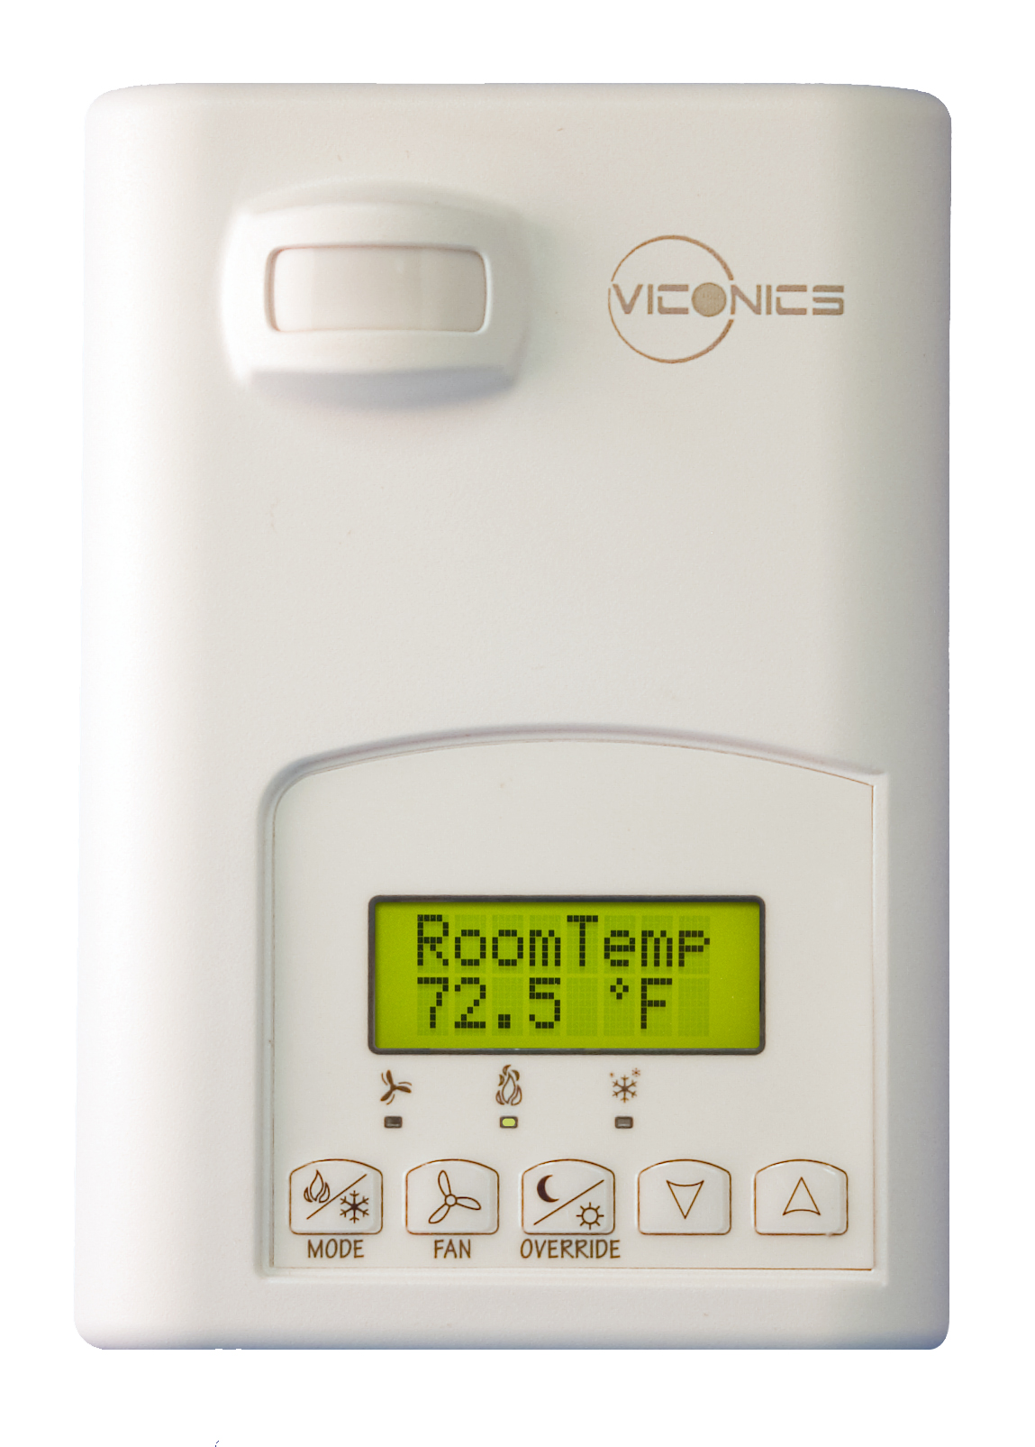
VT7300 Series
Protocol Implementation Conformance Statement (PICS)
Last revision: October 31st, 2011

Vendor Name: Viconics
Product Name: VT7300 Series
Product Model Number: VT7300A5x00B, VT7305A5x00B, VT7300C5x00B, VT7305C5x00B, VT7350C5x00B, VT7355C5x00B,
VT7300F5x00B, VT7305F5x00B,
VT7350F5x00B, VT7355F5x00B,
VT7300M5x00B, VT7301F5x00B
Product Version: 2.5.07
BACnet Protocol Revision: 2 (135-2001)

Product Description

The VT7300 PI thermostat family is specifically designed for fan coil control. The product features a backlit LCD display with dedicated function menu buttons for simple operation. Accurate temperature control is achieved due to the product’s PI proportional control algorithm, which virtually eliminates temperature offset associated with traditional, differential-based thermostats.
Models are available for On/Off, 3 point floating and analog 0 to 10 Vdc control.
All models contain can control three, two or single fan speed. 3 additional inputs are also provided for various functions.

BACnet Standardized Device Profile (Annex L):
□ BACnet Operator Workstation (B-OWS)
□ BACnet Building Controller (B-BC)
□ BACnet Advanced Application Controller (B-AAC)
☑ BACnet Application Specific Controller (B-ASC)
□ BACnet Smart Sensor (B-SS)
□ BACnet Smart Actuator (B-SA)

BACnet Interoperability Building Blocks Supported (Annex K):
BACnet Interoperability Building Block | Supported
Data Sharing-ReadProperty-B (DS-RP-B) | ☑
Data Sharing-ReadPropertyMultiple-B (DS-RPM-B) | ☑
Data Sharing-WriteProperty-B (DS-WP-B) | ☑
Device Management-Dynamic Device Binding-B (DM-DDB-B) | ☑
Device Management-Dynamic Object Binding-B (DM-DOB-B) | ☑
Device Management-DeviceCommunicationControl-B (DM-DCC-B) | ☑

Segmentation Capability:
Segmented Requests Supported | □ | Window Size: | N/A
Segmented Responses Supported | □ | Window Size: | N/A
Standard Object Types Supported:
Object Type | Supported |  | Dynamically  Creatable |  | Dynamically  Deletable |  | Optional  Properties  Supported |  | Writable Properties
Analog Input |  | ☑ |  | □ |  | □ |  | Reliability |  | Out_of_Service
Analog Value |  | ☑ |  | □ |  | □ |  | Reliability |  | Present_Value^{a, b}  Out_of_Serviceª  Object_Name^{c}
Binary Input |  | ☑ |  | □ |  | □ |  | Reliability  Active_Text  Inactive_Text |  | Out_of_Service
Binary Value |  | ☑ |  | □ |  | □ |  | Reliability  Active_Text  Inactive_Text |  | Present_Value  Out_of_Service
Device |  | ☑ |  | □ |  | □ |  | Max_Master  Max_Info_frames |  | Object_Identifier  Object_name  Max_Master
Group |  | ☑ |  | □ |  | □ |  | N/A |  | N/A
Multi-state Value |  | ☑ |  | □ |  | □ |  | Reliability  States_Text |  | Present_Value^{d}  Out_of_Service^{d}

a : Present_Value and Out_of_Service properties are writable for every AV objects except :
- PI Heating Demand (AV21)
- PI Cooling Demand (AV22)
b : Present_Value property for Room Temperature (AV7) and Room Humidity (AV10) is writable only if Room Temp Override (BV8) is enabled and Room Humidity Override (BV11) is enabled respectively.
c : Object_Name property is writable for the following object only :
- Room Temperature (AV7)
d : Present_Value and Out_of_Service properties are writable for every MV objects except :
- Heating Valve Status (MV26)
- Cooling Valve Status (MV27)
- Fan Status (MV28)

Data Link Layer Options:
□ BACnet IP, (Annex J)
□ BACnet IP, (Annex J), Foreign Device
□ ISO 8802-3, Ethernet (Clause 7) (10Base2, 10Base5, 10BaseT, Fiber)
□ ANSI/ATA 878.1, 2.5 Mb. ARCNET (Clause 8)
□ ANSI/ATA 878.1, RS-485 ARCNET (Clause 8), baud rate(s):
☑ MS/TP master (Clause 9), baud rate(s): 9600, 19200, 38400, 76800 (Auto Baud)
□ MS/TP slave (Clause 9), baud rate(s):
□ Point-To-Point, EIA 232 (Clause 10), baud rate(s):
□ Point-To-Point, modem, (Clause 10), baud rate(s):
□ LonTalk, (Clause 11), medium:
□ Other:

Device Address Binding:
Is static device binding supported? □ Yes ☑ No
(Necessary for two-way communication with MS/TP slaves and certain other devices.)

Networking Options:
Router | N/A
Annex H, BACnet Tunnelling | N/A
BACnet/IP Broadcast Management Device (BBMD) | N/A
Does the BBMD support registrations by Foreign Devices? | N/A

Character Sets Supported:

☑ ANSI X3.4 | □ IBM/Microsoft DBCS | □ JIS C 6226
□ ISO 10646 (ICS-4) | □ ISO 10646 (UCS2) | □ ISO 8859-1

If this product is a communication gateway, describe the types of non-BACnet equipment/networks(s) that the gateway supports:
Not applicable.

